INTRODUTION
The purpose of this analysis is to investigate the claim made by the pacific region salespeople that the average cost per square foot of the regional real estate home is above the average cost per square foot of the home sales made by the pacific region salespeople.
SET UP
Population parameter = µ= $275
HO: the average cost per square foot of the home sales is equal to the average cost per square foot of the pacific region
H1: the average cost per square foot of the home sales is above the average cost per square foot of the pacific region.
The test that we will use to test this hypothesis is the t test and the test is left tailed.

DATA ANALYSIS PREPARATION

Mean | 264.016393
Standard Error | 5.11263417
Median | 202.965842
Mode | 206.165334
Standard Deviation | 161.756506
Sample Variance | 26165.1672
Kurtosis | 4.50212972
Skewness | 2.08640264
Range | 967.451596
Minimum | 103.832378
Maximum | 1071.28397
Sum | 264280.409
Count | 1001

cost bins per square foot | frequency
103.8323782-203.8323782 | 506
203.8323782-303.8323782 | 265
303.8323782-403.8323782 | 72
403.8323782-503.8323782 | 52
503.8323782-603.8323782 | 56
603.8323782-703.8323782 | 19
703.8323782-803.8323782 | 14
803.8323782-903.8323782 | 7
903.8323782-1003.8323782 | 9
1003.8323782-1103.8323782 | 1

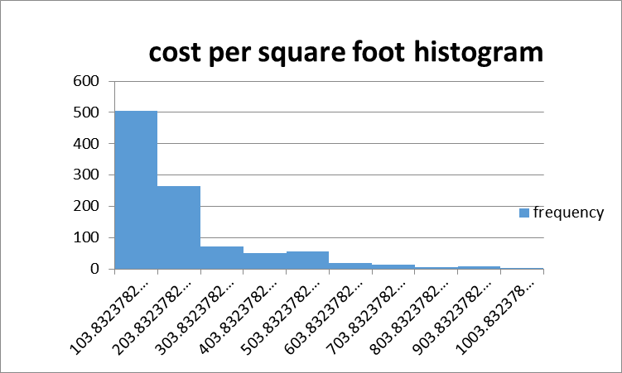

CALCULATIONS
To get the t statistic,
t = Ẋ-µ/S.E
Ẋ= 264.02
µ= 275
S.E =5.11
t = 264.02-275/5.11= -2.1487
To obtain the degrees of freedom = 1001-1=1000
To obtain our p value we will use excel.
Note that our test is left tailed
= T.DIST (-2.1487, 1000, 1)= 0.01595
TEST DECISION
If the p value is greater than our significance level which is 0.05, then we accept the null hypothesis else we reject the null hypothesis.
The p value = 0.01595< α= 0.05
We therefore reject the null hypothesis.
CONCLUSION
From our test decision, we accept the null hypothesis that states that the average cost per foot of the home sales is above the average cost per square foot of the pacific region and conclude that the pacific region salespeople were right

